Q2

With a neat diagram explain the organizations of a computer

Organization of a Computer

A computer is a fast and accurate device, which can accept data, store data, processthem and give, desired results as output. The computer is organized into four units as shown in the following diagram.

[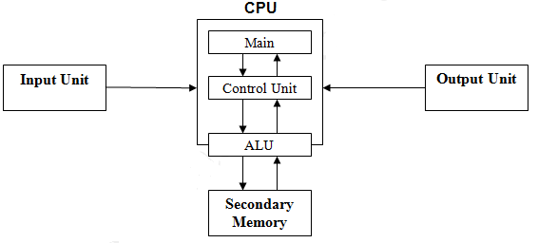](http://2.bp.blogspot.com/-nNCUjYp8f3o/US73LSi3-gI/AAAAAAAAABk/qcBEOjitIH4/s1600/cpu.png)

|  |  |  |  |  |  |  |  |  |  |
| --- | --- | --- | --- | --- | --- | --- | --- | --- | --- |
|  |  |  |  |  |  |  |  |  |  |
|  |  | | | | |  |  |  |  |
|  |  | | |  |  |  |  |  |
|  |  |  | |  |  | |  |
|  |  |  |  |  |  |  |
|  |  |  |  |  |  |  |  |
|  |  |  | | | | |  |
|  |  |  |  |  |

Input Unit:

Any device designed to assist in the entry of data into a computer is known as input device. Input devices convert data from any convenient external format into binary codes that a computer can store and manipulate internally. Some of the most common, most popularly used devices are following.

a) Mouse

b) Light Pen

c) Touch Screen

d) Keyboard

e) Scanner

f) OCR and MICR

g) Bar Code Reader

h) Joy Stick etc.

Output Unit:

Any peripheral device that converts the stored binary coded data into convenient external forms as test and pictures are known as Output device. Some of the most popularly used Output devices are following:

a) Visual Display Unit (Monitor)

b) Printer : Dot Matrix and Impact/Non Impact, Printer, Daisy wheel Printer, Line Printers, Ink-jet, Laser Printer

c) Plotters etc.

Central Processing Unit:

The Central Processing Unit (CPU) is the heart of the computer combined  
in the sys  
with the processing system of a computer. The CPU carries out actions with  
information  
help of Arithmetic-Logic Unit (ALU). This is done following a detailed set of  
arithmetic instructions written in the main memory. It also uses the main memory for  
the memory  
temporary storage of information. Through the channels of information  
specified t  
“Bus”, the CPU instructs various parts called device controllers to transfer  
data between secondary memory and the main memory. The CPU accepts  
the data from the Input unit processes it and gives the result/output to the output device. The data/result can be stored for the use by storing it in the secondary memory. The total operations of the computer is synchronized and controlled by the CPU.  
The processing capacity of a computer is measured in terms the amount of data processed by the CPU in one operation. The CPU has three important sub units.  
 1) Arithmetic-Logic unit  
2) Control Unit  
3) Memory Unit  
 Arithmetic-Logic Unit (ALU): The ALU is an electronic circuit used to carry  
 out the arithmetic operations like addition, subtraction, multiplication and  
division. This unit carries out logical operations like greater than, less than,  
be equal to etc. It performs the operation on the data provided by the input devices. A comparison operation allows a program to make decisions based  
he on its data input and results of the previous calculations.  
 Logical operations can be used to determine whether particular statement is re TRUE or FALSE.  
The ALU operates on the data available in the main memory and sends them back after processing again to main memory.  
Control Unit: The control unit coordinates the activities of all the other units ed in the system. Its main functions are to control the transfer of data and  
information between various units and to initiate appropriate actions by the  
arithmetic-logic unit. Conceptually, the control unit fetches instructions from the memory, decodes them, and directs them to various units to perform the  
on specified tasks.

Memory Unit: The main memory is also called primary memory, is used to store data temporarily. Although, the CPU is the brain behind all the operations in the computer, it needs to be supplied with the data to be processed and the instructions to tell it what to do. Once the CPU has carried out an instruction, it needs the result to be stored. This storage space is provided by the computer’s memory. Data provided by the input device, and the result of that processed data is also stored in the memory nit. This main memory is like a scratch pad. The storage capacity of the memory is generally measured in megabytes.  
8 Bits = 1 Byte  
1024 Bytes= 1 Kilobyte (KB)  
1 024 Kilobytes= 1 Megabyte (MB)  
1024 Megabytes= 1 Gigabyte (GB)  
Different kinds of primary memory are Random Access Memory (RAM) and Read Only Memory (ROM). You can read and write data in RAM but the data is volatile or temporary that is whenever the power is switched off the contents of RAM is lost so its is required to store the data in the secondary memory if the data is required for the future use. But you can only read the data from ROM and you can not write any thing into it and the data is permanent. The manufacturer himself has written the data in it initially.

Secondary Memory:

This is the permanent memory. The data stored in it is permanent. But you can delete the data if you want. There are different kinds of secondary storage devices available. Few of them are Floppy disks, Fixed (hard) disks and Optical disks etc.

a) Floppy Disk

b) Fixed or Hard Disk

c) Optical Disk like: CD (Compact Disk) DVD (Digital Versatile Disk)

d) Magnetic Tape Drive

Q1

The computer systems can be classified on the following basis:

1. On the basis of size.   
2. On the basis of functionality.   
3. On the basis of data handling.

**Classification on the basis of size**

1. **Super computers :** The super computers are the most high performing system. A supercomputer is a computer with a high level of performance compared to a general-purpose computer. The actual Performance of a supercomputer is measured in FLOPS instead of MIPS. All of the world’s fastest 500 supercomputers run Linux-based operating systems. Additional research is being conducted in China, the US, the EU, Taiwan and Japan to build even faster, more high performing and more technologically superior supercomputers. Supercomputers actually play an important role in the field of computation, and are used for intensive computation tasks in various fields, including quantum mechanics, weather forecasting, climate research, oil and gas exploration, molecular modeling, and physical simulations. and also Throughout the history, supercomputers have been essential in the field of the cryptanalysis.   
   eg: PARAM, jaguar, roadrunner.
2. **Mainframe computers :** These are commonly called as big iron, they are usually used by big organisations for bulk data processing such as statics, census data processing, transaction processing and are widely used as the servers as these systems has a higher processing capability as compared to the other classes of computers, most of these mainframe architectures were established in 1960s, the research and development worked continuously over the years and the mainframes of today are far more better than the earlier ones, in size, capacity and efficiency.   
   Eg: IBM z Series, System z9 and System z10 servers.
3. **Mini computers :**These computers came into the market in mid 1960s and were sold at a much cheaper price than the main frames, they were actually designed for control, instrumentation, human interaction, and communication switching as distinct from calculation and record keeping, later they became very popular for personal uses with evolution.   
   In the 60s to describe the smaller computers that became possible with the use of transistors and core memory technologies, minimal instructions sets and less expensive peripherals such as the ubiquitous Teletype Model 33 ASR.They usually took up one or a few inch rack cabinets, compared with the large mainframes that could fill a room, there was a new term “MINICOMPUTERS” coined   
   Eg: Personal Laptop, PC etc.
4. **Micro computers :** A microcomputer is a small, relatively inexpensive computer with a microprocessor as its CPU. It includes a microprocessor, memory, and minimal I/O circuitry mounted on a single printed circuit board.The previous to these computers, mainframes and minicomputers, were comparatively much larger, hard to maintain and more expensive. They actually formed the foundation for present day microcomputers and smart gadgets that we use in day to day life.   
   Eg: Tablets, Smartwatches.

**Classification on the basis of functionality**

1. **Servers :** Servers are nothing but dedicated computers which are set-up to offer some services to the clients. They are named depending on the type of service they offered. Eg: security server, database server.
2. **Workstation :** Those are the computers designed to primarily to be used by single user at a time. They run multi-user operating systems. They are the ones which we use for our day to day personal / commercial work.
3. **Information Appliances :** They are the portable devices which are designed to perform a limited set of tasks like basic calculations, playing multimedia, browsing internet etc. They are generally referred as the mobile devices. They have very limited memory and flexibility and generally run on “as-is” basis.
4. **Embedded computers :** They are the computing devices which are used in other machines to serve limited set of requirements. They follow instructions from the non-volatile memory and they are not required to execute reboot or reset. The processing units used in such device work to those basic requirements only and are different from the ones that are used in personal computers- better known as workstations.

**Classification on the basis of data handling**

1. **Analog :** An analog computer is a form of computer that uses the continuously-changeable aspects of physical fact such as electrical, mechanical, or hydraulic quantities to model the problem being solved. Any thing that is variable with respect to time and continuous can be claimed as analog just like an analog clock measures time by means of the distance traveled for the spokes of the clock around the circular dial.
2. **Digital :**A computer that performs calculations and logical operations with quantities represented as digits, usually in the binary number system of “0” and “1”, “Computer capable of solving problems by processing information expressed in discrete form. from manipulation of the combinations of the binary digits, it can perform mathematical calculations, organize and analyze data, control industrial and other processes, and simulate dynamic systems such as global weather patterns.
3. **Hybrid :**A computer that processes both analog and digital data, Hybrid computer is a digital computer that accepts analog signals, converts them to digital and processes them in digital form.

Q3

What do you mean by instruction set?

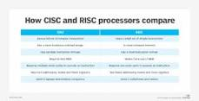

An instruction set is **a group of commands for a central processing unit (CPU) in machine language**. The term can refer to all possible instructions for a CPU or a subset of instructions to enhance its performance in certain situations.

### CPU (Central Processing Unit):

CPU or central processing unit in computer is an electronic circuitry that carries out the instruction given by a computer program. CPU in computer execute instruction by performing basic arithmetic, logical, control and I/O operations as required per instruction. CPU in computer is considered to be the brain of the computer. The speed and efficiency of a computer mostly depends on it’s CPU.

**Suggested Reading:**

1. [What is CPU? What are the functions of CPU?](https://onlineclassnotes.com/2016/07/what-is-cpu-what-are-functions-of-cpu.html)

2. [Write the working principles of 8086 microprocessor.](https://onlineclassnotes.com/2011/06/write-working-principles-of-8086.html)

CPU in computer can execute instructions on it only. But as the program can be very large, CPU loads the program in the main memory (RAM) and then fetches instructions one by one from the memory to the CPU registers and executes them.

## Bored with text? Watch the video instead.

## Steps in Instruction Execution by CPU:

Six steps are involved in execution of an instruction by CPU. However, not all of them are required for all instructions.

1. Fetch instruction
2. Decode information
3. Perform ALU operation
4. Access memory
5. Update register file
6. Update the Program Counter (PC)

### Step 1: Fetch instruction

Execution cycle starts with fetching instruction from main memory. The instruction at the current [program counter (PC)](https://onlineclassnotes.com/2011/06/draw-expanded-structure-of-von-neumann.html) will be fetched and will be stored in [instruction register (IR)](https://onlineclassnotes.com/2011/06/draw-expanded-structure-of-von-neumann.html).

### Step 2: Decode instruction

During this cycle the encoded instruction present in the IR (instruction register) is interpreted by the decoder.

### Step 3: Perform ALU operation

ALU ([Arithmetic Logic Unit](https://onlineclassnotes.com/2016/07/discuss-organization-and-functions-of-alu-or-arithmetic-and-logic-unit.html)) is where two operands in the instruction will be operated on given operator in the instructions. Such as, if the instruction was to add two numbers, then here the addition will happen.  ALU take two values and output one, the result of the operation.

[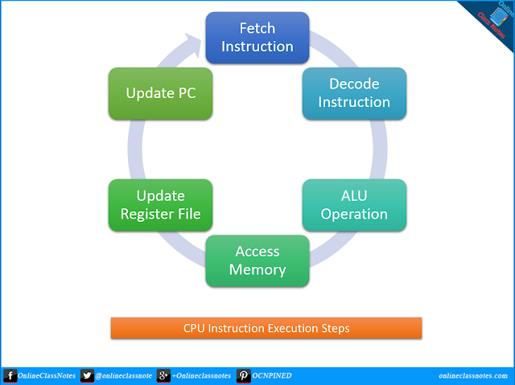](https://3.bp.blogspot.com/-vKYm7wFSXW0/WApmohuzwzI/AAAAAAAAFfQ/x_rUtU9_Vc43nERbUiS3u02ysNr9OukgwCLcB/s1600/steps-in-instruction-execution-by-cpu.png)

### Step 4: Access memory

There are only two kind of instructions that access memory: LOAD and STORE. LOAD copies a value from memory to a register and STORE copies a register value to memory. Any other instruction skips this step.

### Step 5: Update Register File

In this step, the output/result of the ALU is written back to the register file to update the register file. The result could also be due to a LOAD from memory. Some instructions don’t have results to store. For example, BRANCH and JUMP instructions do not have any results to store.

### Step 6: Update the PC (Program Counter)

Ultimately, at the end of the execution of the current instruction, we need to update the program counter (PC) to the address of the next instruction, so that we can go back to step 1 where the CPU will fetch instruction. However, the program counter might need to be set to other memory address than the next one if the instruction was BRANCH or JUMP

Q4